1. **QUESTION**

[AMBITIOUS]

Create a Progressive Web App that allows readers to keep up with all topics, news, and events they care about, from one single place. The platform should bring news and stories from around the world together in a magazine format.

**Source Code GIT Repository:**

**Web Browser Link:**

[**https://github.com/Ajay-Kumar-Aspiring-Minds-Round-2/newsapp**](https://github.com/Ajay-Kumar-Aspiring-Minds-Round-2/newsapp)

**GIT Clone Link:**

[**https://github.com/Ajay-Kumar-Aspiring-Minds-Round-2/newsapp.git**](https://github.com/Ajay-Kumar-Aspiring-Minds-Round-2/newsapp.git)

**Technology Stack:**

    



Key Features of News App – **News can be viewed of nearly 54 Countries.**

**3**

**1**

**2**

General News

Technology News

Business News

Entertainment News

4

**5**

Science News

**6**

Health News

7

**9**

Search News

**8**

App Settings

Sports News

**Application Architecture Diagram**

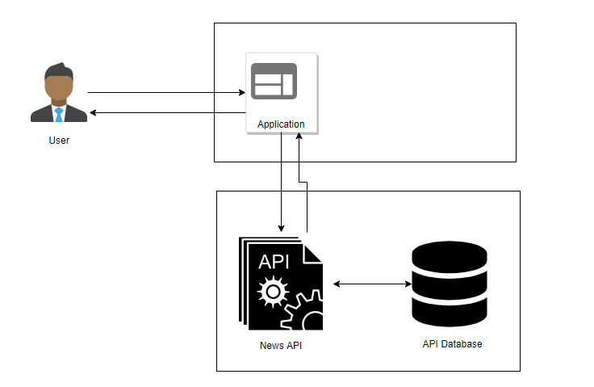

**Progressive Web Apps – NEWS APP (TOP NEWS, EVENTS & STORIES)**

* **Progressive Web Apps** are web apps that use emerging web browser APIs and features along with traditional progressive enhancement strategy to bring a native app-like user experience to cross-platform web applications.
* **Progressive Web Apps** take advantage of the latest technologies to combine the best of web and mobile apps.
* It is intended to work on any platform that uses a standards-compliant browser, including both desktop and mobile devices.

**PWA Audit Report with Lighthouse (Open-Source Tool from Google)**

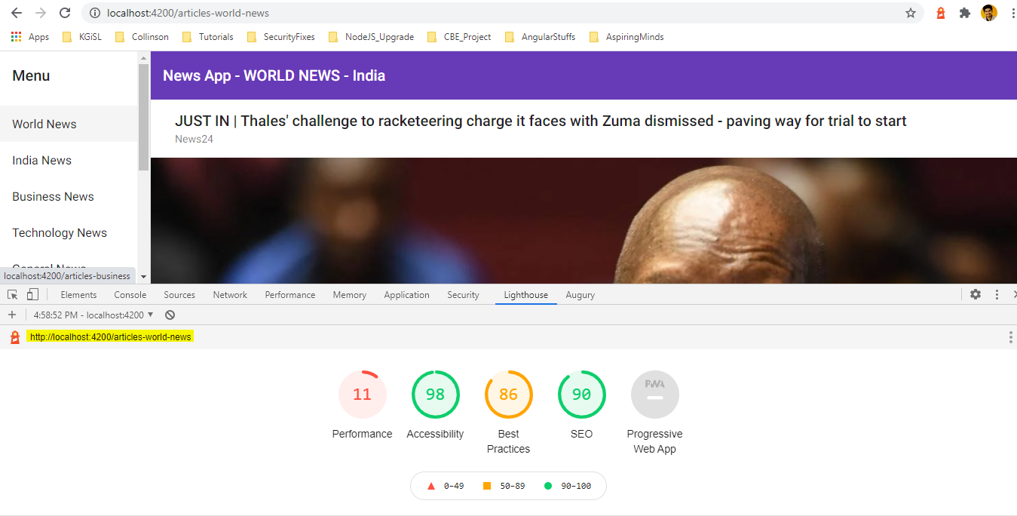

**Router Tree Structure of Components:**

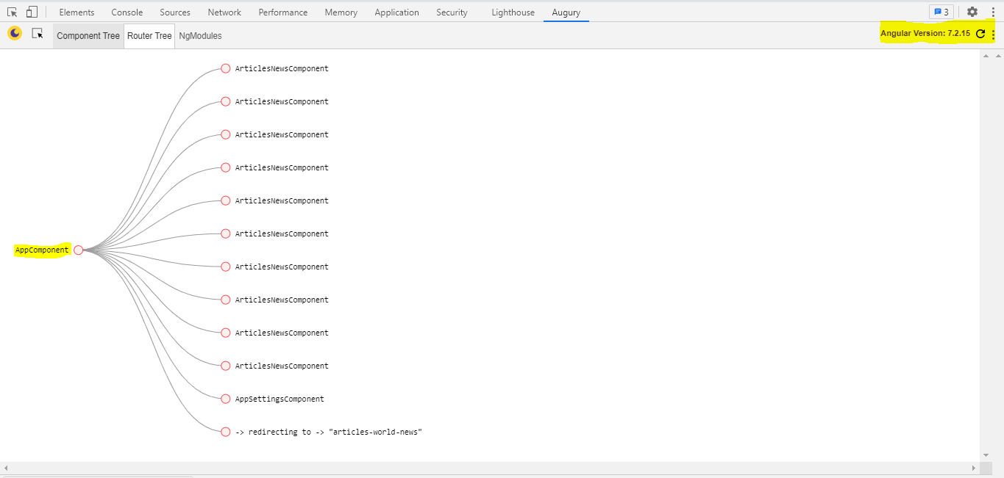

**Country Modification under App Settings:**

* User can change the **default country** under **App Settings**. **Default country** is **India**.
* Based on selected country under the app settings - news for **business, technology, general, health, science, entertainment & sports** are fetched from the Open Source News API Service and parsed to display in the App User Interface.
* **User can view news and stories from around the world to nearly 54 countries.**

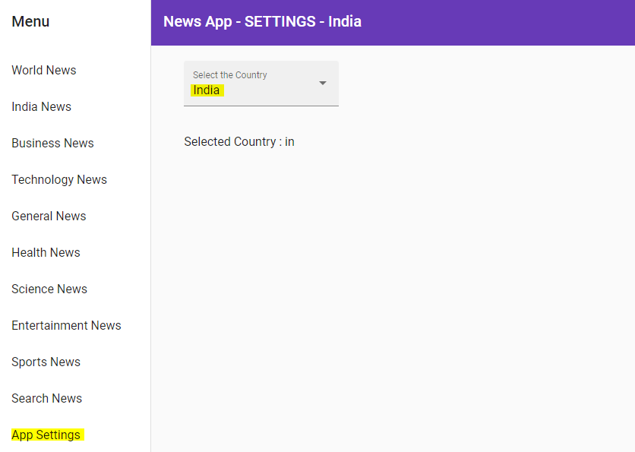

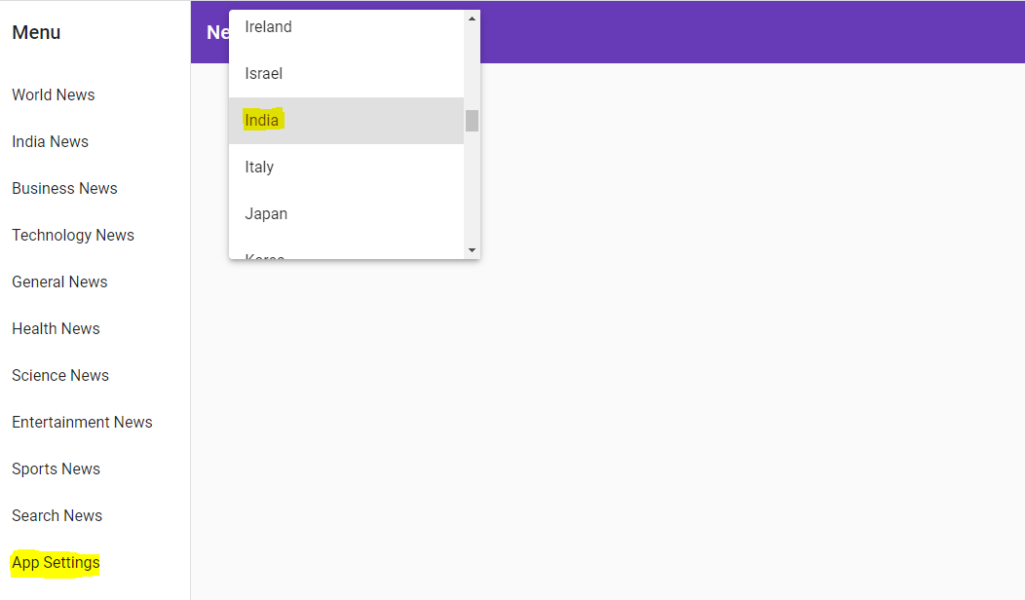

**Business News for the selected country - India**

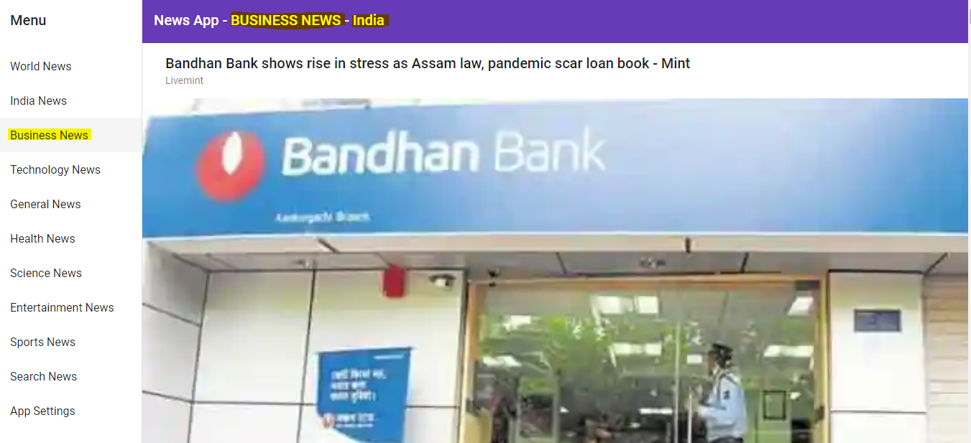

**Science News for the selected country - India**

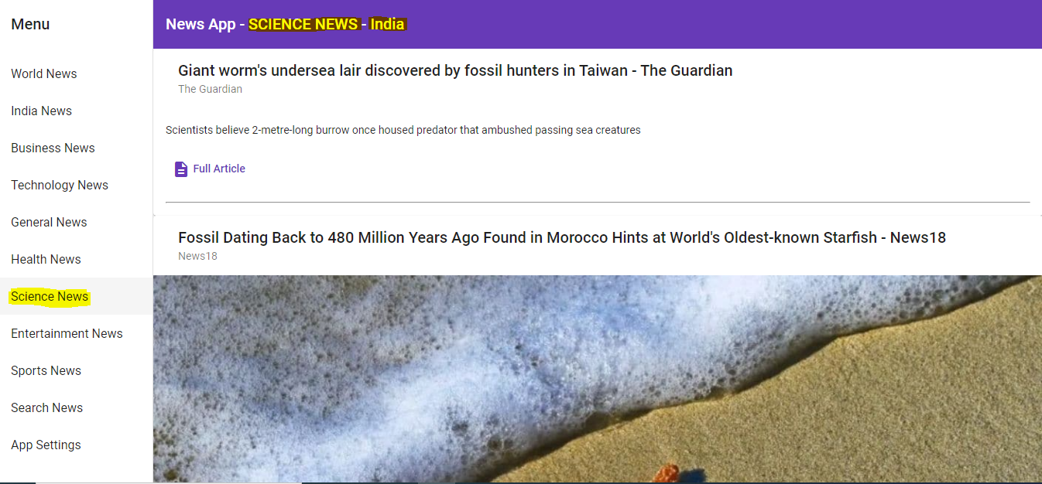

**Search News:**

* User can search for any news under this menu option.
* User can query as BBC or ABC NEWS or RAHUL DRAVID etc.,

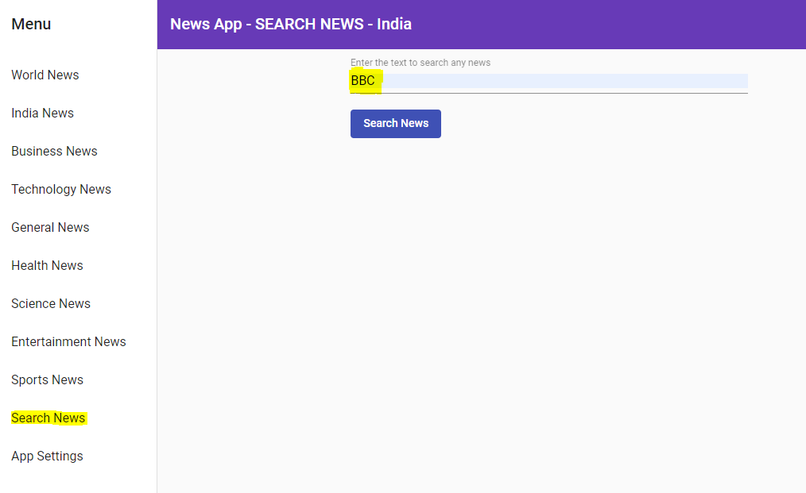

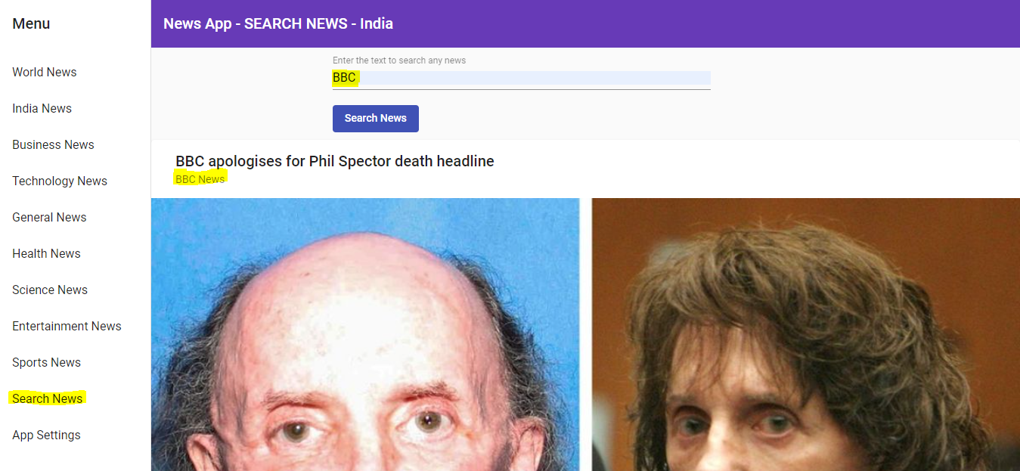

**Mobile Browser View of News App:**

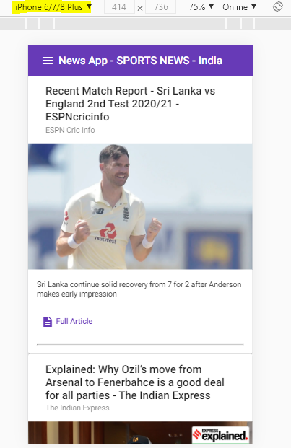

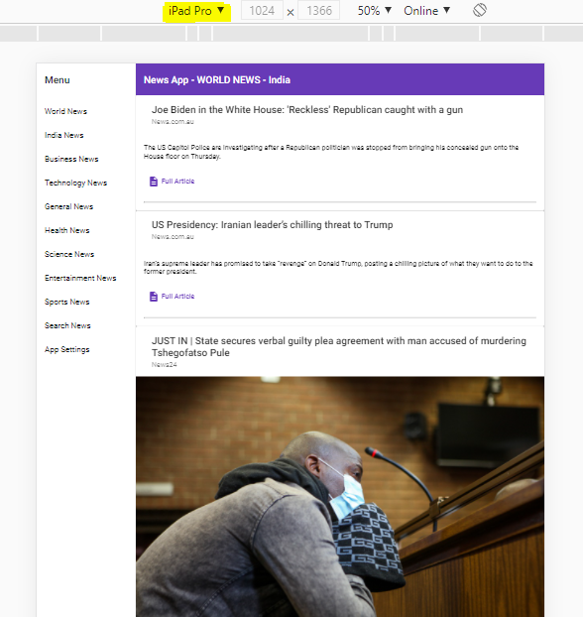

**News API (Open Source API):**

News API has 2 main endpoints:

1. **Top headlines - /v2/top-headlines**
   * Returns breaking news headlines for a country and category, or currently running on a single or multiple sources. This is perfect for use with news tickers or anywhere you want to display live up-to-date news headlines and images.

* This endpoint provides live top and breaking headlines for a country, specific category in a country, single source, or multiple sources. You can also search with keywords. Articles are sorted by the earliest date published first.

1. **Everything - /v2/everything**

* We index every recent news and blog article published by over 50,000 different sources large and small, and you can search through them with this endpoint. This endpoint is better suited for news analysis and article discovery, but can be used to retrieve articles for display too.
* Search through millions of articles from over 50,000 large and small news sources and blogs. This includes breaking news as well as lesser articles.
* This endpoint suits article discovery and analysis, but can be used to retrieve articles for display, too.

We also have a minor endpoint that can be used to retrieve a small subset of the publishers we index from:

1. **Sources - /v2/sources**

* Returns information (including name, description, and category) about the most notable sources we index. This list could be piped directly through to your users when showing them some of the options available.
* This endpoint returns the subset of news publishers that top headlines (/v2/top-headlines) are available from. It's mainly a convenience endpoint that you can use to keep track of the publishers available on the API, and you can pipe it straight through to your users.

**Sample News API Request & Response for Top headlines in the US**

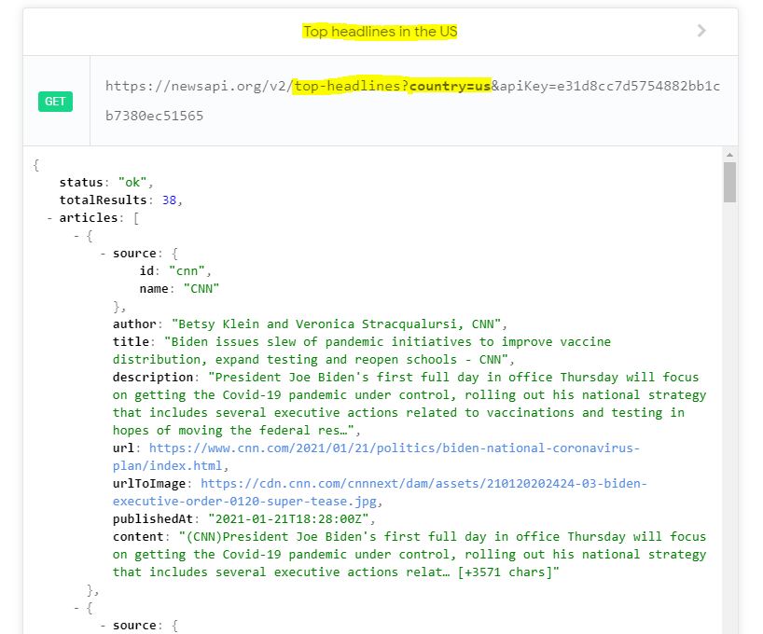

**Sample News API Request & Response for Top business headlines from Germany**

